Press release

Palsgaard Brazil names new CEO as it gears up for growth

October 1, 2025
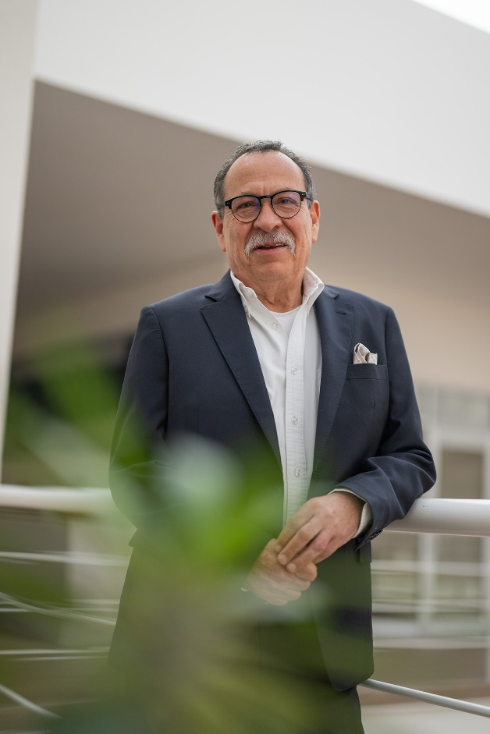
MARECHAL CÂNDIDO RONDON, Paraná, Brazil – Emulsifier and stabiliser specialist Palsgaard has appointed Miguel Hidalgo as its new CEO in Brazil as it targets further success in the country.

Hidalgo, who starts the role on October 1, has 30 years’ experience at Palsgaard and has served as chairman of the company’s Brazilian operation since 2018. His previous roles also include CEO of Palsgaard Mexico and Regional Director of the Americas.

He takes on the position as Palsgaard aims to become the leading supplier of emulsifiers and speciality ingredients for the food industry in Brazil.

With a primary focus on emulsifier and stabiliser solutions for cakes, chocolates, and lipids, the business is preparing for a new phase of growth under Hidalgo’s leadership.
Miguel Hidalgo, CEO of Palsgaard Brazil

Hidalgo said: “I am delighted to take on my new role as we prepare for further growth. We want to ensure that Palsgaard Brazil is recognised for the exceptional quality and functionality of our emulsifiers and speciality ingredients, and for providing the best technical, application, development and logistics services.”

Palsgaard opened its first sales office in Brazil in 2008 and expanded its operations when it acquired a majority stake in bakery ingredients company Candon in 2016. It completed a full takeover in 2022.

Palsgaard Brazil has production facilities at the site in Paraná state, as well as selling ingredients produced by its international affiliates. Customers also have access to application and development centres plus local and international technical professionals, who are on hand to offer tailored formulation support.

Hidalgo added: “Our experts have extensive knowledge of different industrial processes and how to get the best from emulsifiers and stabilisers. Together, we can help customers create and reformulate products that are perfectly tailored to their needs – ensuring quality solutions that will satisfy their target consumers.”

For more information, please contact:

Mette Dal Steffensen, Corporate Identity & Communications Manager, Palsgaard A/S
mds@palsgaard.dk | +45 2073 4534

About Palsgaard
At Palsgaard, our world – and our niche area of expertise – is plant-based emulsifiers, and has been for over 100 years. Ever since we invented the plant-based emulsifier in 1917, we’ve been pushing the frontiers of food science, developing emulsifiers and stabilisers that set new standards in our industry.
We are proud to play a small but crucial role in delivering delicious foods for a growing population, and also offer our solutions to non-food markets such as polymers and personal care. Through close collaboration with our customers, we help reduce the use of scarce resources, minimise food waste, and lower environmental impact – all while maintaining product quality and production efficiency.
Our heart-working culture is all about making business personal. We work side by side with our customers to understand their challenges and co-create customised, added-value solutions – from innovating new products to reformulating recipes and improving ESG performance.
Our ESG strategy is embedded in everything we do, from recipe optimisation and energy savings to transparent reporting aligned with current standards. As niche experts, we combine deep technical knowledge with hands-on support through our application centres and pilot plants. Our collaborative approach builds long-term trust and peace of mind – ensuring supply security, food safety, and compliance across global markets.
We are owned by the Schou Foundation and have more than 800 colleagues in 20 countries, as well as six factories and nine application centres on four continents. In 2024, we reported a turnover of 314 million EUR (2.3 billion DKK).

For more information, visit www.palsgaard.com

